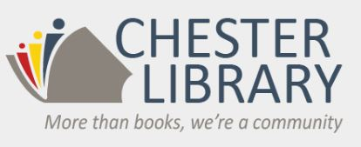
Is proud to continue this popular program for Chester residents

The Chester Library Mentoring Program
Open to all Bragg School students
(and Chester residents in 3rd-5th grade)

- Mentoring can focus on homework, a particular school subject or study and organizational skills
- Mentoring will be provided by high school students and supervised by a certified teacher
- Students will be assigned a high school student mentor who will work with them each week
- Mentoring sessions will be held on Mondays starting Oct. 21st
- Chromebooks will be available for access to curriculum and homework
- This is a free service sponsored by the Chester Library and the Chester Municipal Alliance!

Join us for a Parent Information Meeting at the library on Monday,
Oct. 7th at 6 pm to learn more and to register for this program!

Contact MaryAnn Burden (maryann.burden@chesterlib.org) if you cannot attend the meeting but are interested in registering for this program!

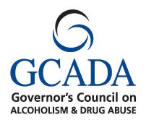
Chester Library
250 W. Main St.
Chester, NJ 07930
908-879-7612
www.chesterlib.org

